**MSc Project - Reflective Essay**

|  |  |
| --- | --- |
| **Project Title:** | Use chatgpt to generate NPC conversations in the unity environment |
| **Student Name:** | **Jiaao Cai** |
| **Student Number:** | **230173750** |
| **Supervisor Name:** | Laurissa Tokarchuk |
| **Programme of Study:** | Computer game |

This article is used to reflect on the errors and problems that occurred throughout the project.

Project goal problem

The first is the project goal: The initial project goal is set to:

Stage1:Connect chatgpt to my game. Train the chatgpt behind different NPCS separately to differentiate the dialogue and behavior patterns of NPCS.Finish this stage will be a successful project and OK to submit.

Stage2: Explore how much freedom chatgpt can and should give players by adjusting chatgpt's parameters. Specific exploration direction: intelligent dialogue, quest generation, PCG, and ending orientation.

But later the project goals were modified to:

Connect chatgpt to unity. Train the chatgpt behind different NPCS separately to differentiate the dialogue and behavior patterns of NPCS. Connect two chatgpt simultaneously in unity. Generate entities based on gpt responses. Briefly describe the difference between 3.5 and 4o.

The reasons are as follows:

1. Due to personal reasons, I do nothing for a month, and the entire scheduled time for stage 2 was taken up and disappeared.

2. Wrong estimation of one's own abilities and the difficulty of the task. I think I can quickly learn the gpt API application and connect it to unity.

3. Stage 1 at that time did not consider many specific details, and these issues can be expanded and explored during actual operations. To a certain extent, the definition documentation is too general.

How to improve these issues in the next development process:

1. Leave more time and space for yourself. No one knows what kind of unexpected things may happen during the process, so it is a good choice to reasonably extend the deadline of your project. In my current situation, I should set the deadline at twice the expected working hours.

2. You should explore more previous research before writing the proposal report. Better understand the difficulty of the project and the core of the project. It is even better to write a preliminary research report that is longer than the actual paper requires before starting the project research. This not only helps you complete the relevant work faster when writing a paper, but also gives your research a clear position. This makes it easy to find the blank parts of the current research direction and prevent wasted effort.

Time planning issues

The previous gantt chart was:

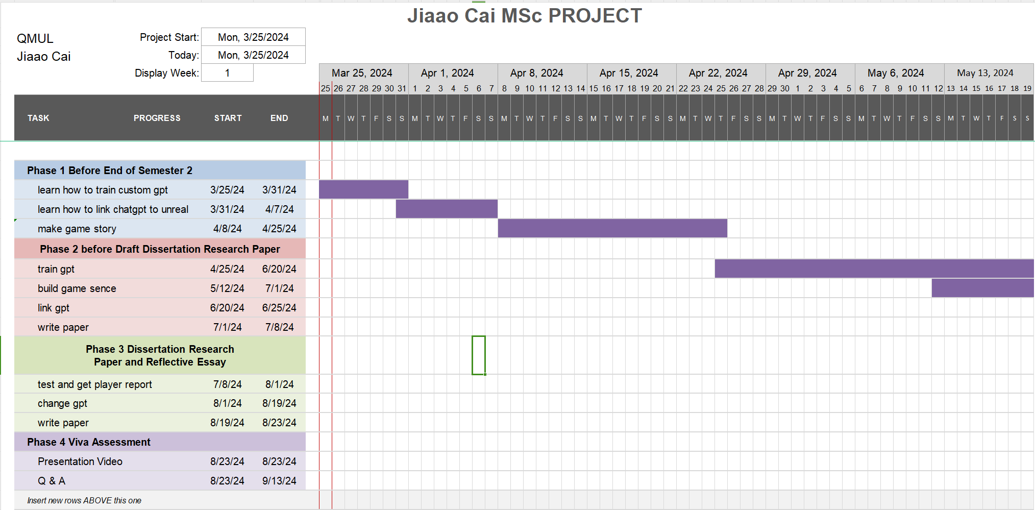

This form has never been updated in subsequent work. Gantt chart is a good tool for controlling work progress but it should be continuously updated and tracked. Otherwise, the form made at the beginning is just a superficial project and actually does not play its due role at all. I think the gantt chart should be updated at least once a week during the work period and if there is any substantial progress or additional work that is not shown in the original gantt chart, it should be added to the chart.

Communication issues

According to the teacher's requirements, you should contact the teacher at least once a week or every two weeks to check the progress of the project and let the teacher provide help and suggestions. However, various problems actually occurred during the entire project, resulting in the failure to conduct online meetings at this frequency:

1. I was too busy before May due to course reasons and could not do it.

2. In June, due to physical reasons, I basically did nothing for the whole month.

3. I participated in online meetings quite frequently in July but only once every two weeks. Because there was too much work in arrears, the progress every week was not smooth. Sometimes there is no new development and it doesn't feel like talking to the teacher at all. But in fact, you should participate more and even if there is no progress, you should let the teacher know. The teacher should be able to help me give me some suggestions, which would be much better than trying hard on my own.

Problems in the project

At the beginning of the project development, I was very happy when I discovered a very useful unity package that had been integrated by others, because it saved me a lot of time. However, I did not read all the code well when using it. Understanding the code logic of the entire package caused frequent problems when using it. I even thought that this package was not well written and I needed to rewrite it myself. However, after studying the guidance documents provided to users by OpenAi and reading the referenced packages in depth, I found that it actually provides many basic functions. Package has completely encapsulated the deep code that actually interacts with the OpenAi api using unitywebquest and provided a variety of interfaces. I only need to call these interfaces externally and make appropriate extensions and modifications. This useless power consumed me for nearly 2 weeks. Completely ruined my work schedule. This kind of thing can be avoided completely, and you should thoroughly read their instructions before using other people's packages next time. At the same time, you should also read their code carefully to fully understand the running logic of the package. It will save a lot of trouble to apply or develop after this.

Regarding the optimisation of the GPT model, I first came into contact with the My GPT function provided by the webUI ChatGPT. At that time, the development process was relatively smooth. The whole function is very convenient. You can upload multiple additional knowledge documents, and there are also assistants to help develop the correct prompt. But after the development was completed, there was a problem when I wanted to import it into Unity. In fact, this GPT is just a webUI. This webUI does not provide an API interface for me to call. At first, I thought that I only needed to replace the URL in the code with the GPT I made, but in fact it would cause the program to crash. I explored many ways, and when I asked the GPT customer service, the answer given by the customer service was that they would not provide me with an API even if I was just for academic purposes. But they suggested that I use the API method of OpenAI. When I was training the API, I couldn't find how to pass the PDF in at the beginning. But in fact, it was because I relied too much on uploading on the web. I should use the code to upload it to GPT together with the prompt before each communication. But I took too many detours in this process. I also tried to encapsulate the GPT of the two NPCs I developed into an API and then connect it to Unity. But this is not compliant in the first place, and secondly, you need to build a cloud server on the computer to run it. The most important thing is that I have to redevelop the package to call my API. This will bring me a lot of work. Fortunately, I studied the code carefully and found out how to upload files from the code.

Although the whole process of developing and connecting gpt was very tortuous, I also gained a lot. First of all, I think that there is nothing wrong with the development process of developing gpt on the web page and finally finding that it cannot be used. I think it is caused by openai's failure to explain it clearly. But it also gave me another result in the paper: chatgpt has good enough functionality and interactivity when facing non-professionals. If the player only needs to develop an assistant or an NPC in a text game (DnD), it is completely unnecessary to connect gpt to unity, but just use webUI. As for the latter problem, it is a good idea to actively communicate with the official staff when looking for a solution to the problem. Simply searching for solutions on the Internet may lead you in the wrong direction.

Emergency

At the last moment, the computer where I wrote the paper had a problem of not being able to boot up. And I did not follow a good backup habit. My code has three backups: cloud, computer, and mobile hard disk. But because the paper was written too quickly, I did not have time to back it up to the other two places. I had no choice but to start writing the paper again. This wasted another 2 days of my time. From this incident, it can be concluded that it is still necessary to save it in the cloud at least once every half a day.

Future work

Due to time constraints, many good works could not be completed. Here are some directions that can be developed.

1. Better identify the output of gpt and generate items in the game. Currently, regular expressions are used to identify the output of gpt. I think this method is fine and is the best text recognition method. However, if the output of gpt is not restricted, there are too many types of text output by gpt. Due to time constraints, I cannot add all possibilities to the detection. But if time permits, we should give up the restrictions on gpt and let gpt generate freely within the scope of the story. As long as all possibilities are taken into account, we can ensure that the output of gpt can allow us to detect and successfully generate objects.

2. More can be generated. Currently, only generated objects are detected. It can also expand the generation of tasks, maps, and even new NPCs. In this way, we can even use a small number of NPCs to control the progress and development of the entire game.